LAB 1:

Task1:
Based on the description of task 1, I know that attacker did not use TCP and UDP so I open the protocol hierarchy to look for any protocols that the attacker could use.
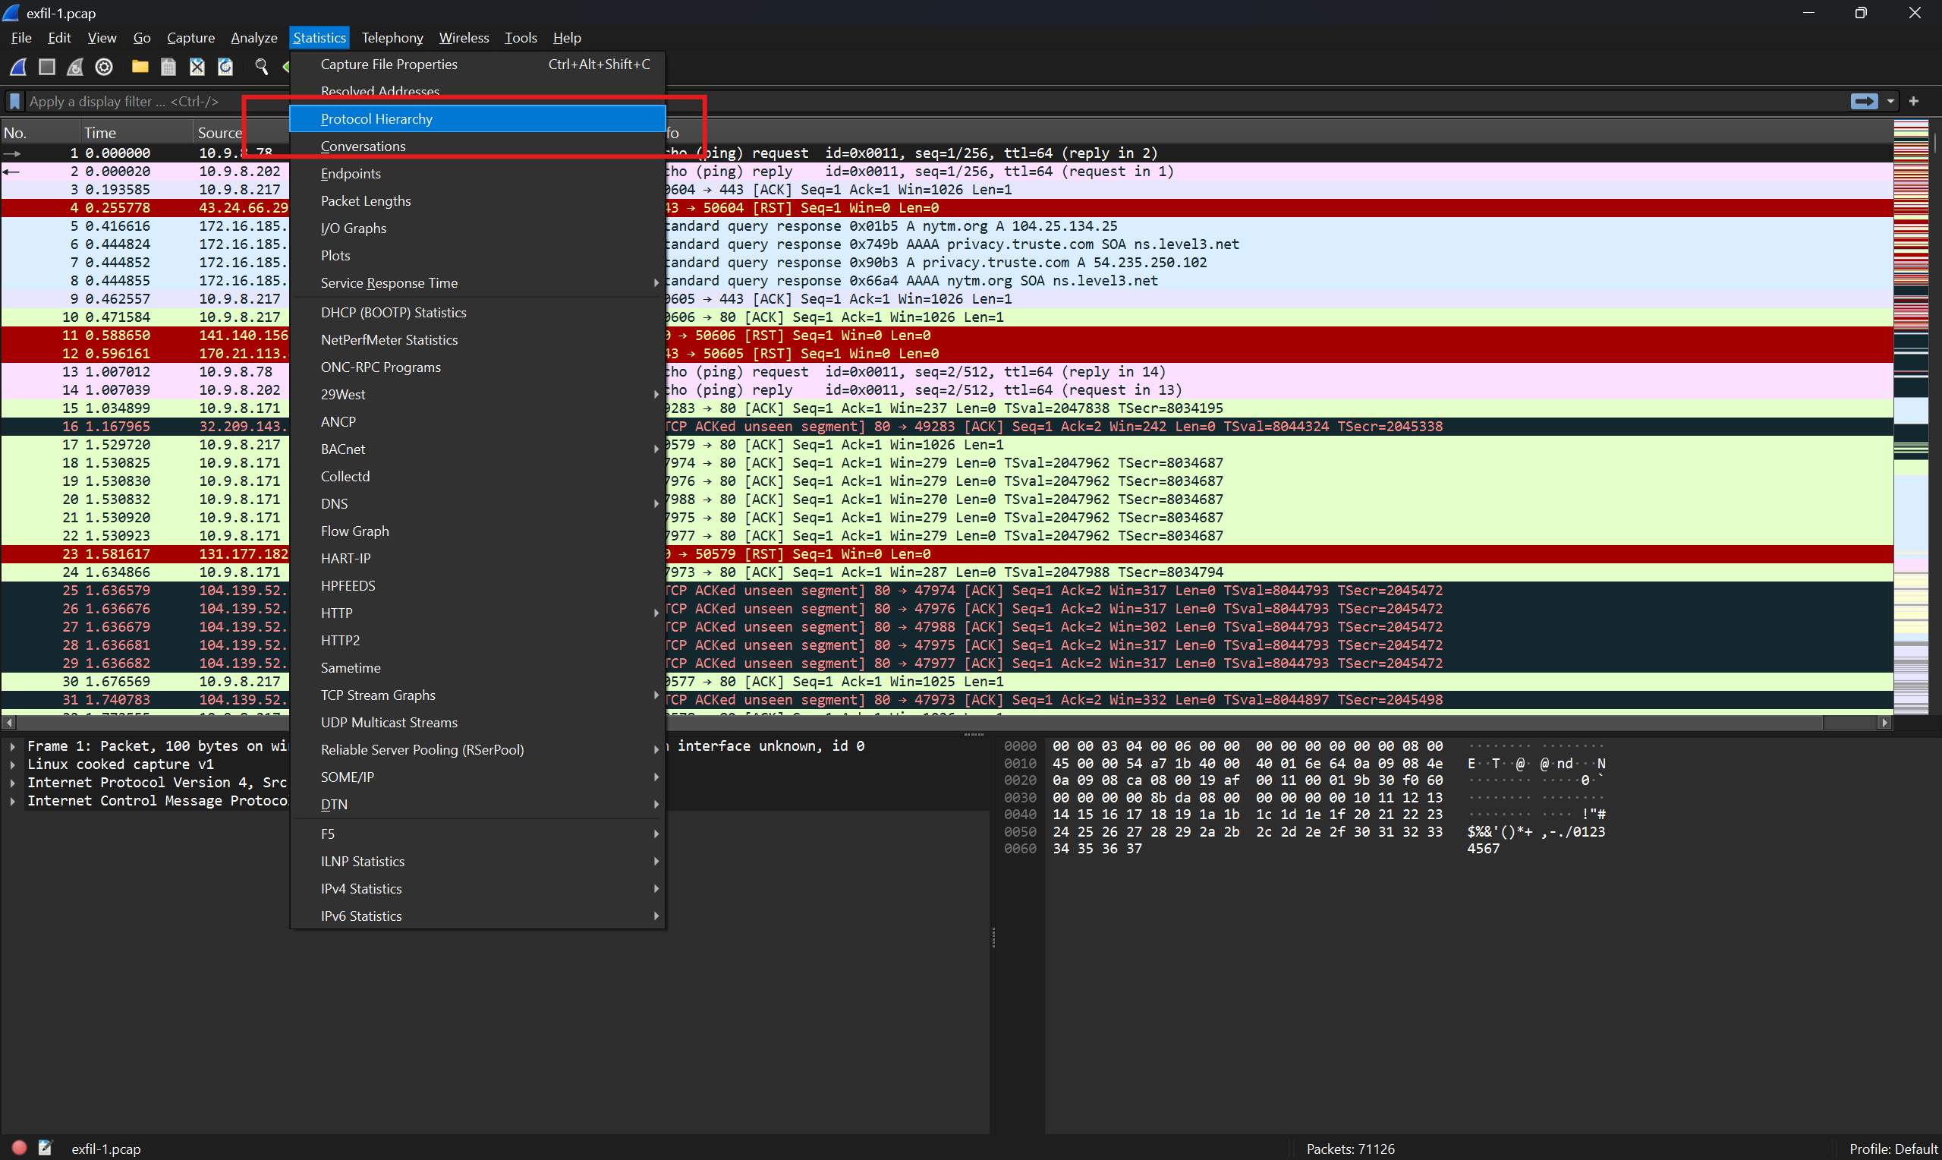
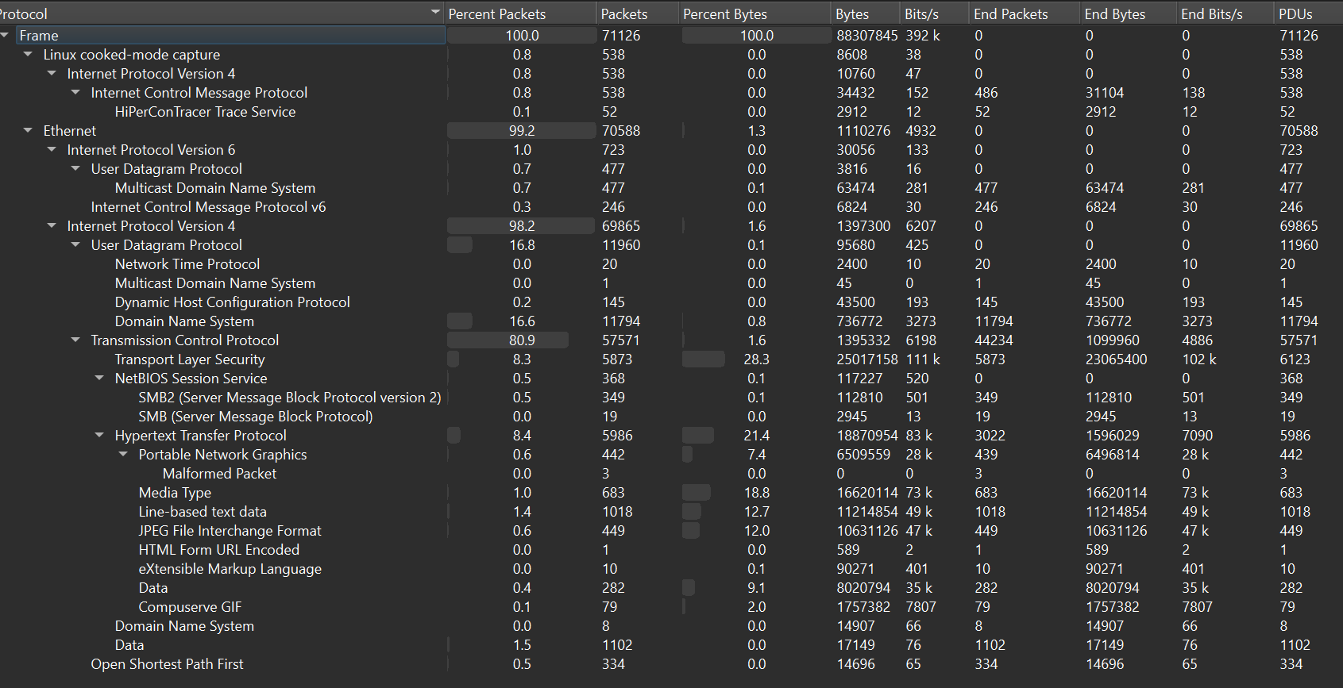
Then to my experience I think that icmp might be used to send data by attacker
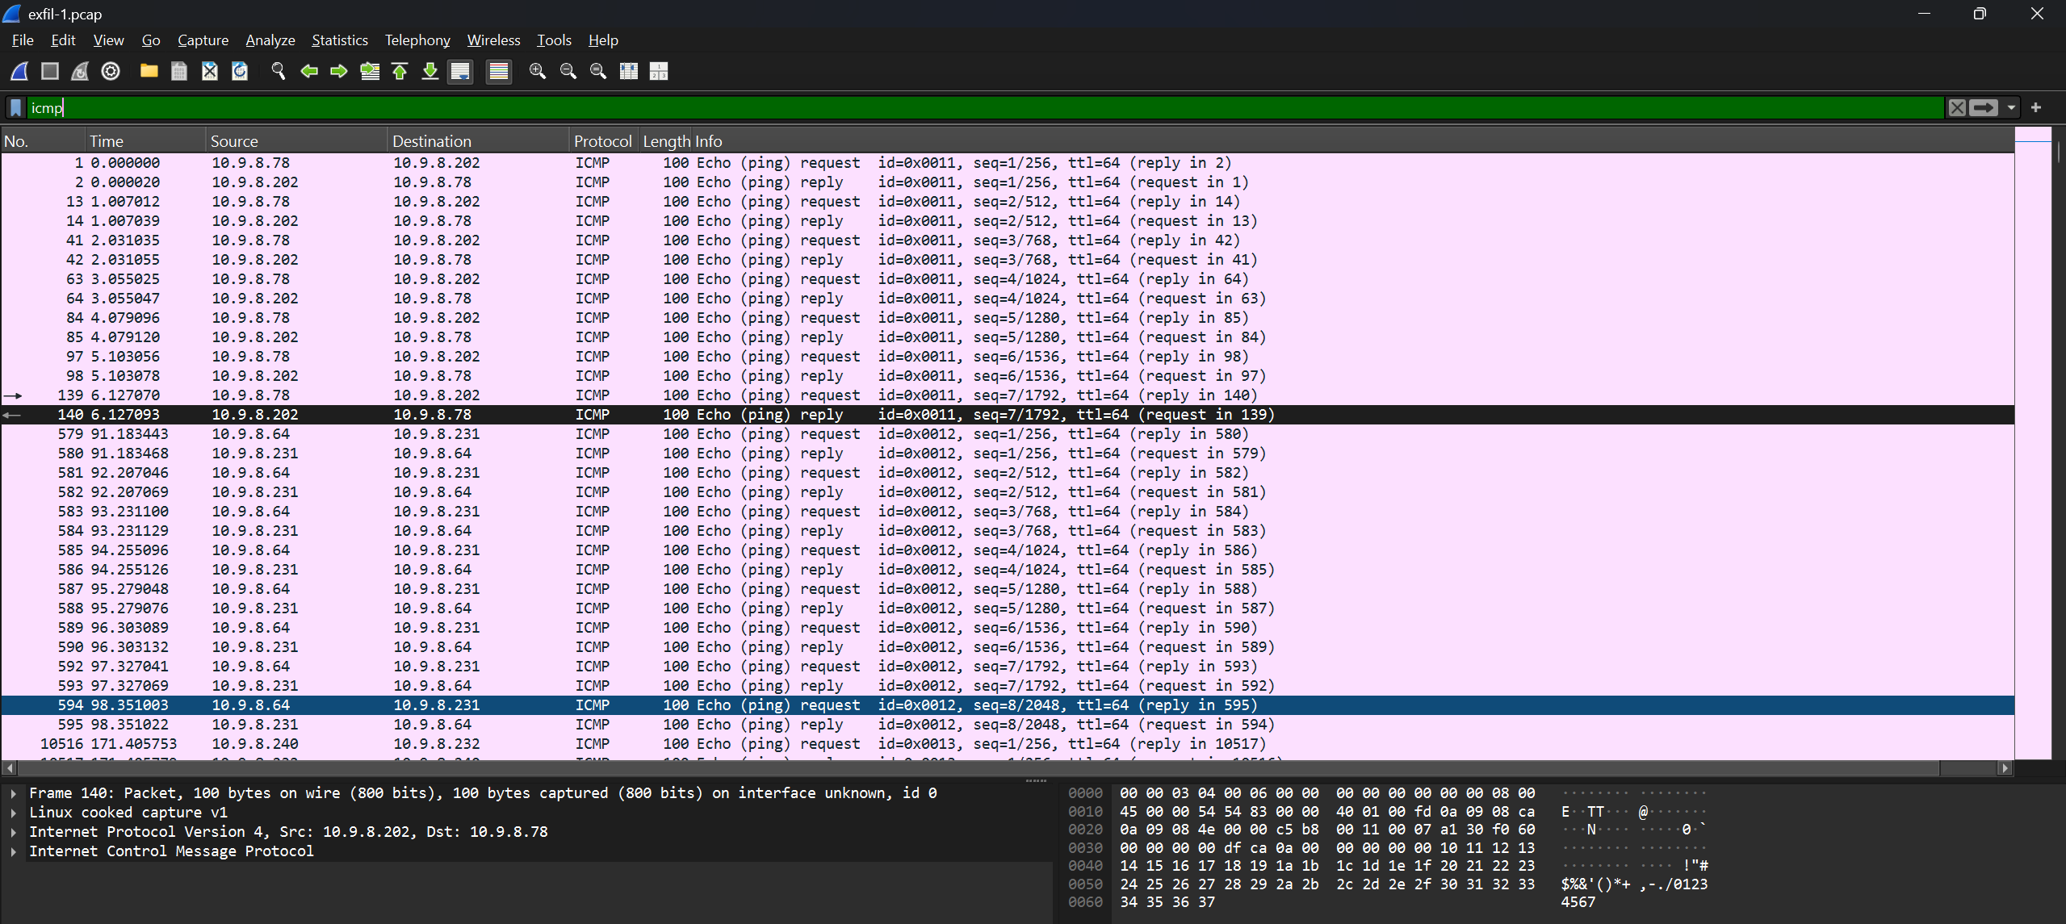
So I use tshark to dump all the data from icmp to see if there is anything suspicious.
tshark -r exfil-1.pcap -Y "icmp" -T fields -e data.data > icmp_data.txt
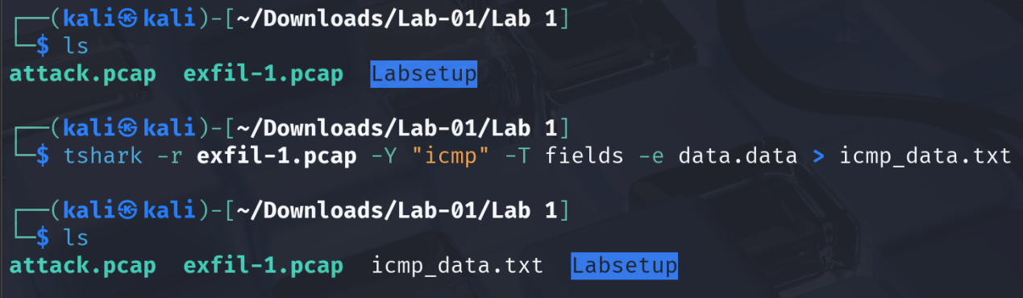
Now. Lets open the txt file and see what in there
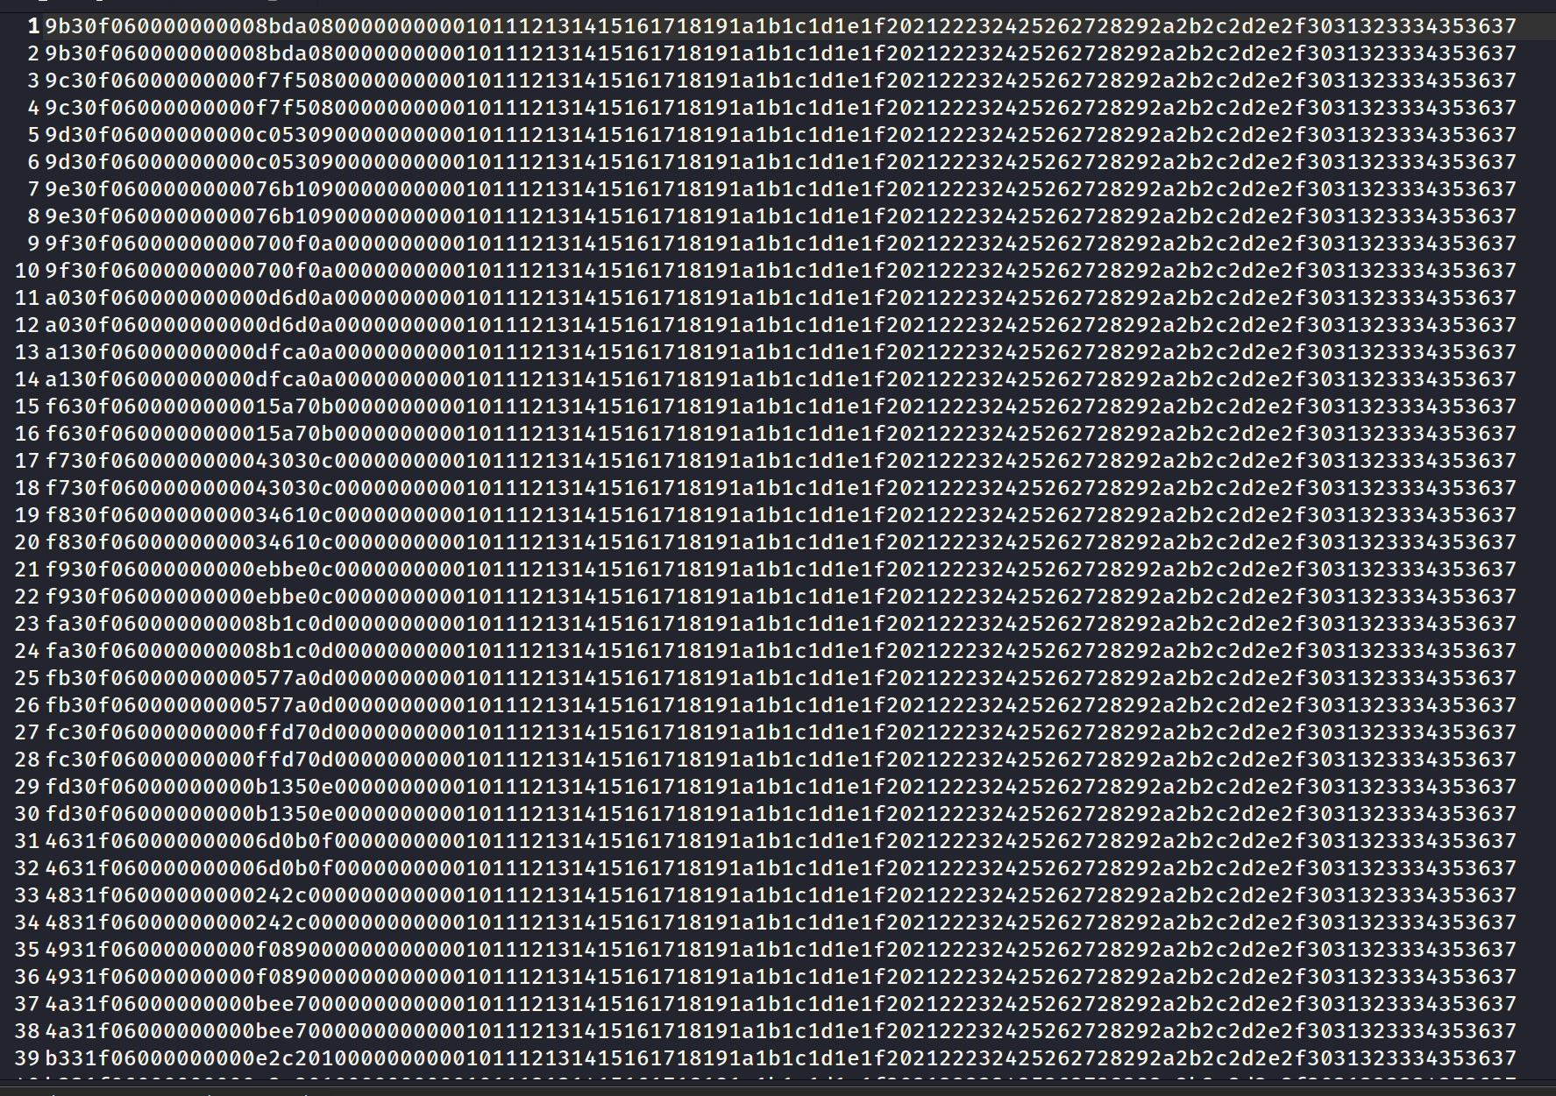
It contains a lot of hex characters so I decided to decode it with Cyberchef and what is the message of the attacker.
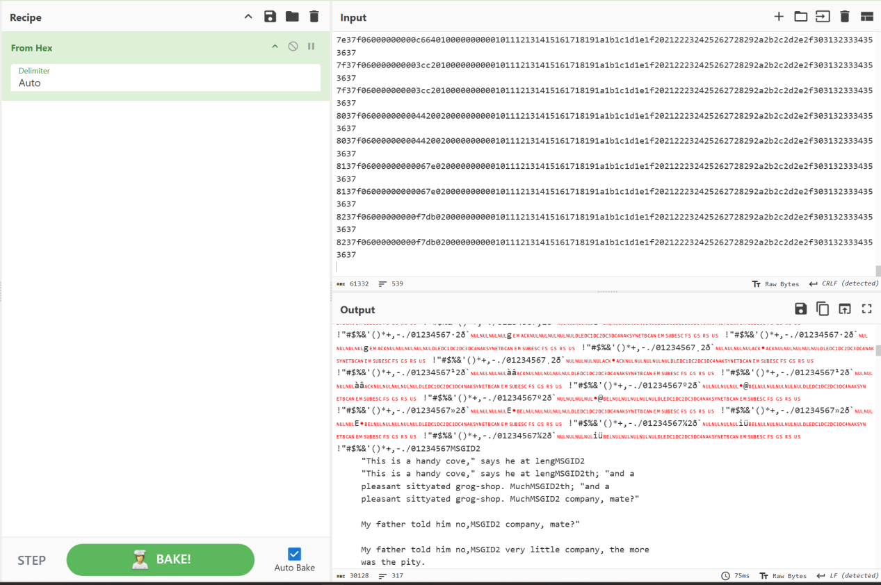
So good so far, beside the trash texts, I can see that there are a lot of plaintext that is human-readable.
After remove all the trash texts, this is what I received.
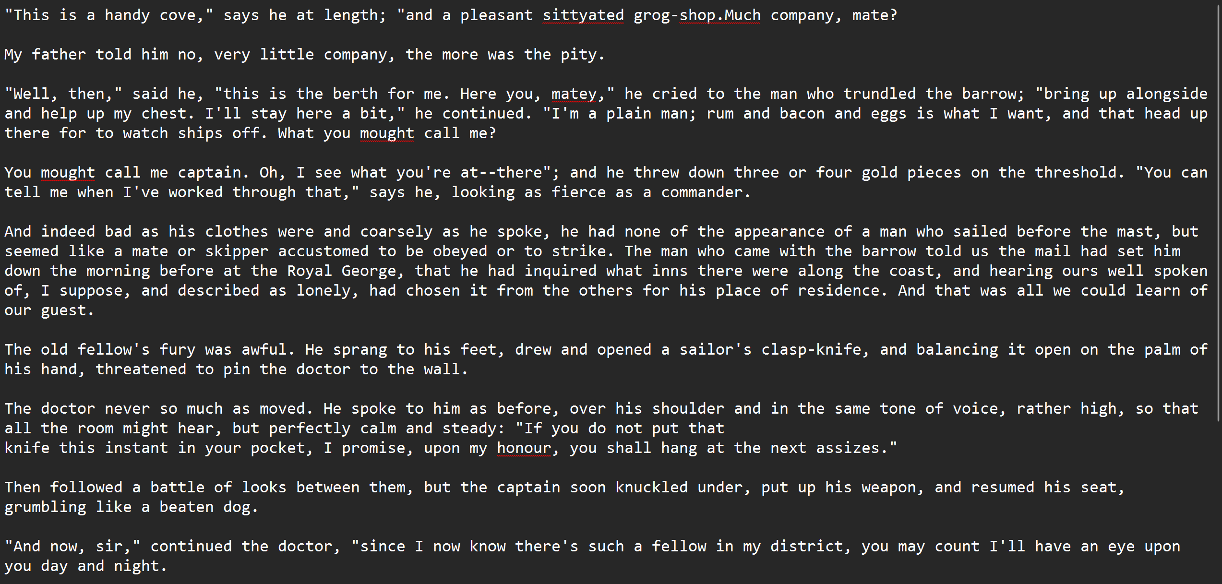

So after Task 1, I learn that about icmp can be used by attacker to hide the encrypted message without anyone know about it. That can be useful in some leak data exfiltration I think, that is interesting.

Task 2:
So in this task, I have to find the attacker ip and its attack method. After reviewing the CVE about this D-Link camera, and look around the pcap file, I know that I will have to examine the http request to find the attackers ip and what they were trying to do.
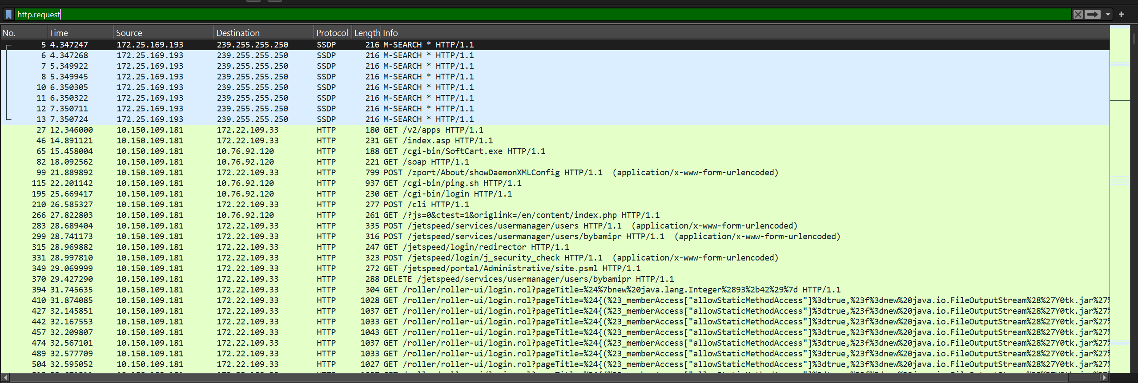
After analyzing the http.request, I know that the attacker IP is 10.150.109.181 and its target IP is 10.76.92.120 and 172.22.109.33.
In this http.request filter, I found that attacker try to fuzz the endpoint to find the vulnerabilities of the endpoint but most of them are http.response 404 and 400.
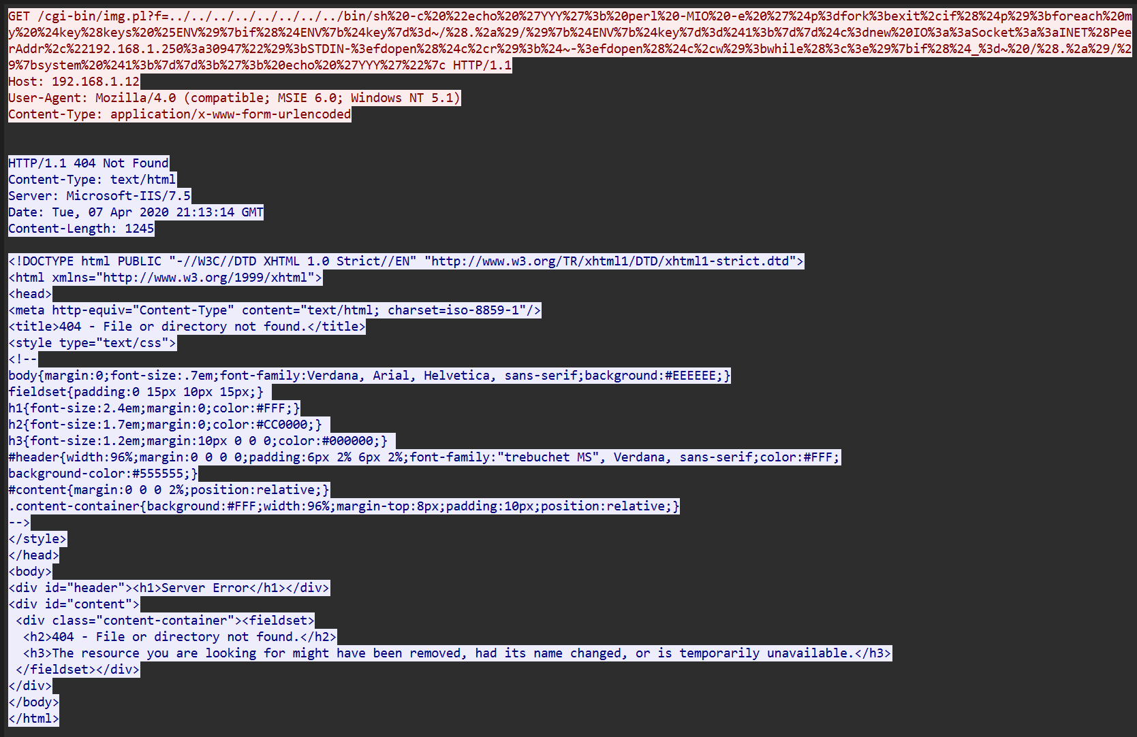
This is one the example. So I decided to see the http.response 200 OK to examine what would happen.
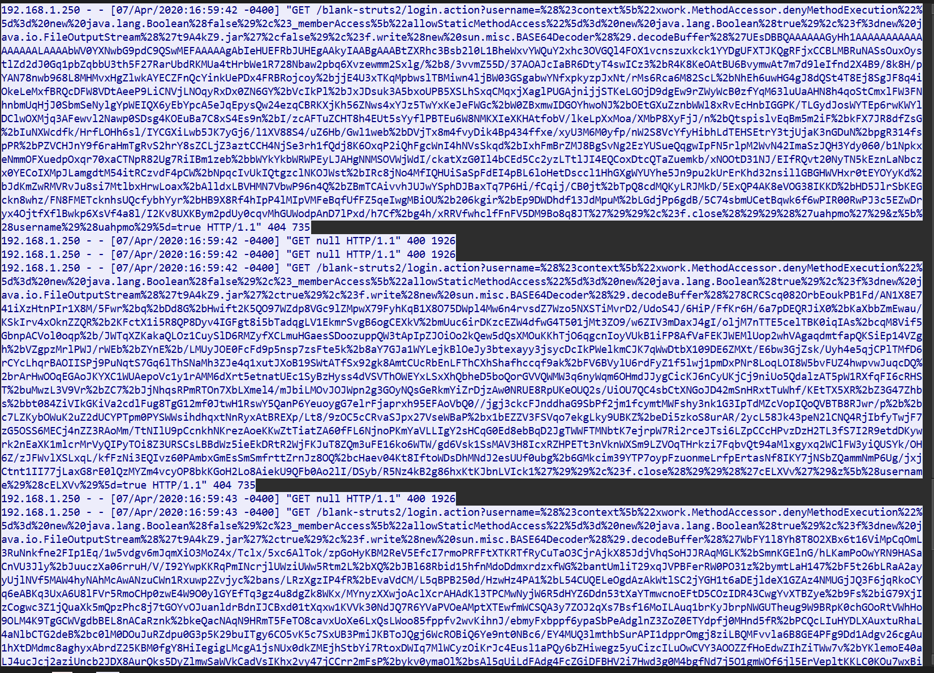
I found that in one of these http.response == 200, I found some packets with 200 OK from IP 172.22.109.33 response OK with OGNL injection with lead to RCE.
But after that I have analyzed the TCP packets to look for reverse shell but it show nothing.

In conclusion, the atatcker ip is 10.150.109.181 and its attack vector is trying to fuzz the endpoint for vulnerabilities, and when the attacker receive http.response==200, the attacker do nothing after that.
Woah this task made my brain burn out, I almost got cooked, this task really interesting also it really hard for beginner to forensics (haha).

Task 3:
Move to task 3, we will learn how to use scapy from here:
Getting the docker run.
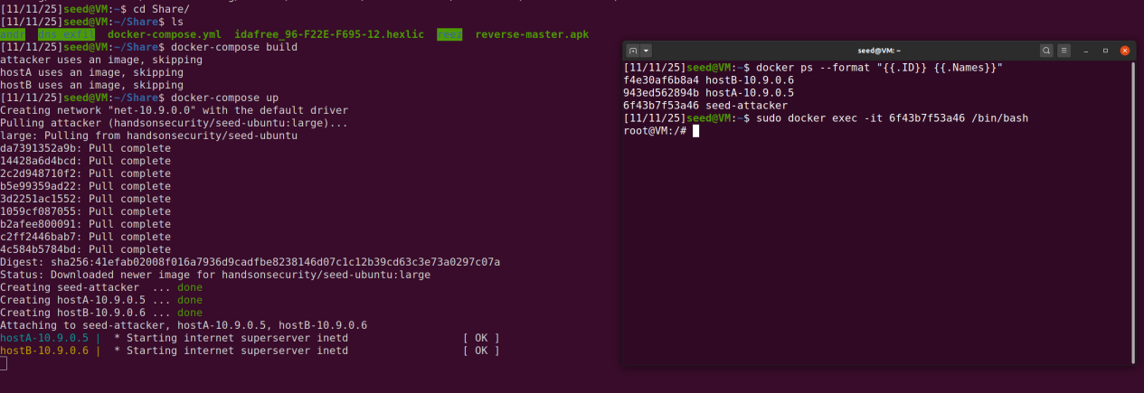
Lets move to the next step, identify the attacker network interface then put it into the sniffer.py code.
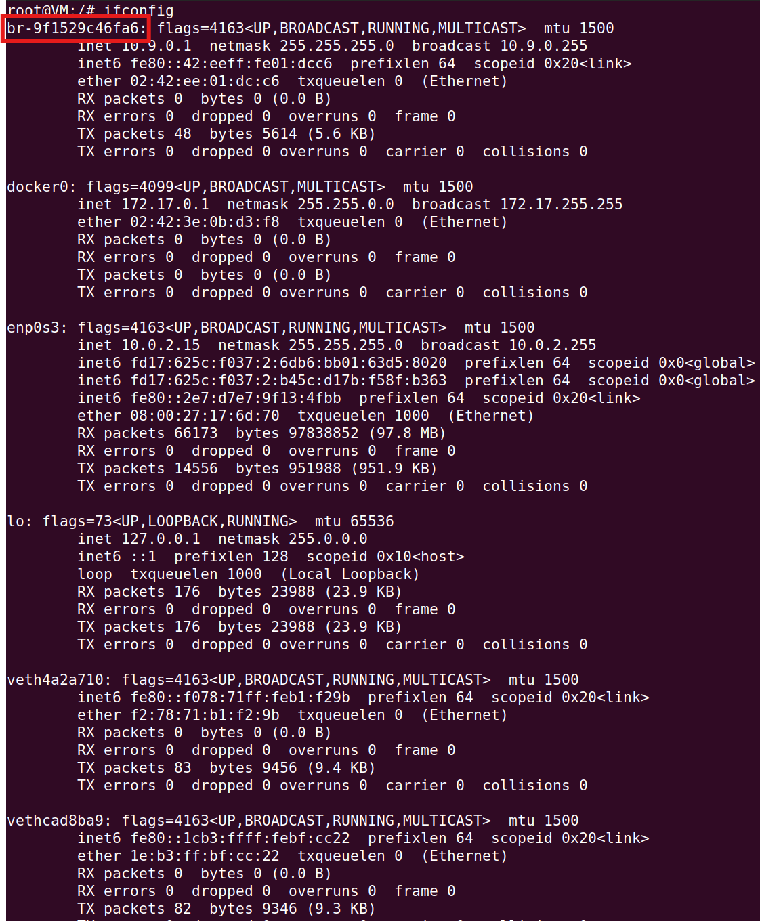
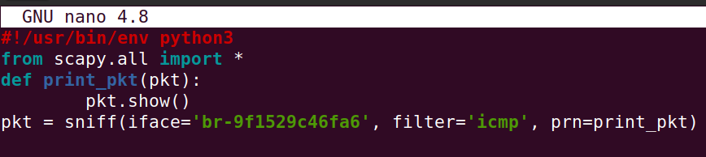
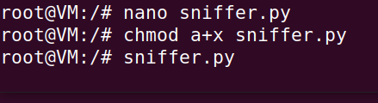
Okay, I have give it permission and then run the file, but we all see that there is nothing appear at all, because there are not any network traffic that go through the network. So we have to go into the host machine and generate the traffic. Also the code just filter icmp so it can only capture icmp packet.
I have run the host B in my terminal and then ping to the host A.
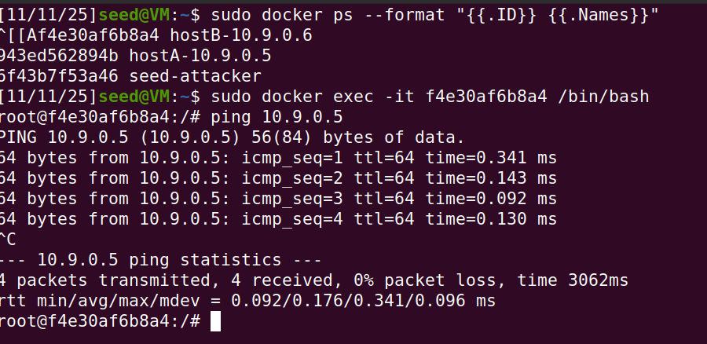
Host B ping to Host A log.
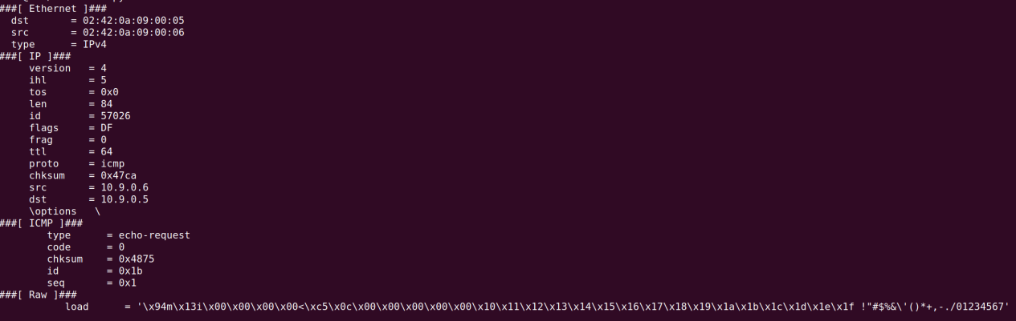

This is the host A terminal
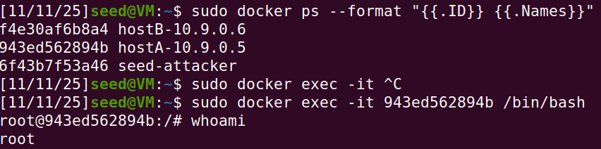
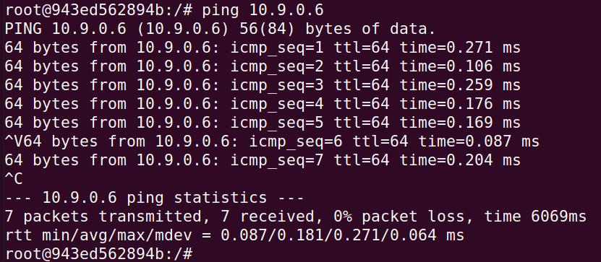
Ping from host A to host B log.
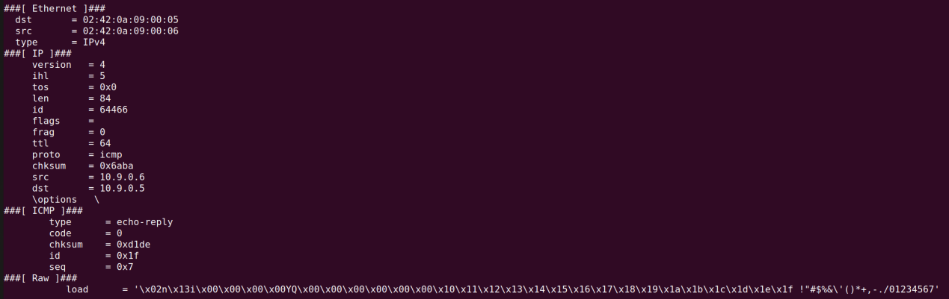

Task 4:
Move to task 4, in this task I will have to capture telnet (port 23) and icmp in one scapy python file.
Below is the code that I have modified.
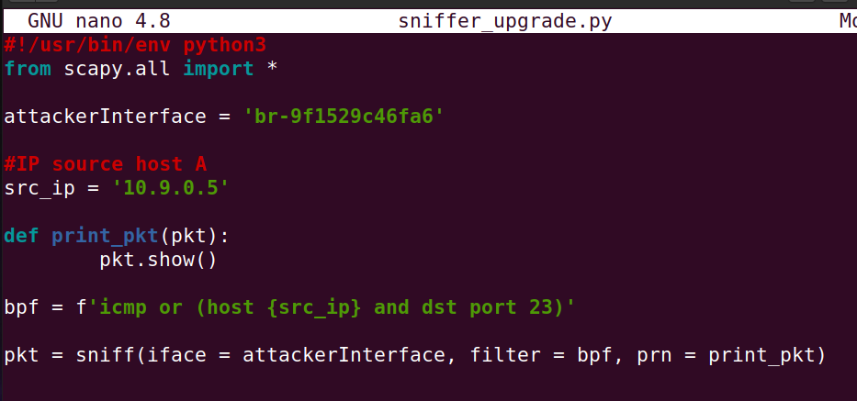
The source IP I will use host A first and then will be host B .
I have given the file execute permission, then ran it.
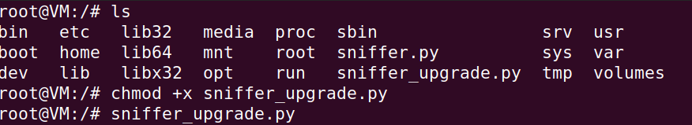
Generate the ping from host A to host B.
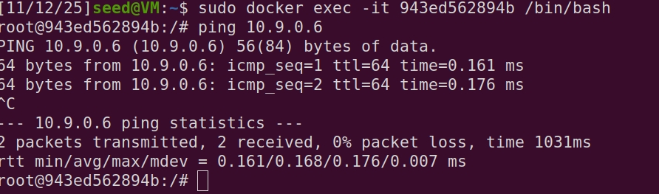
Ping from host A to host B log.
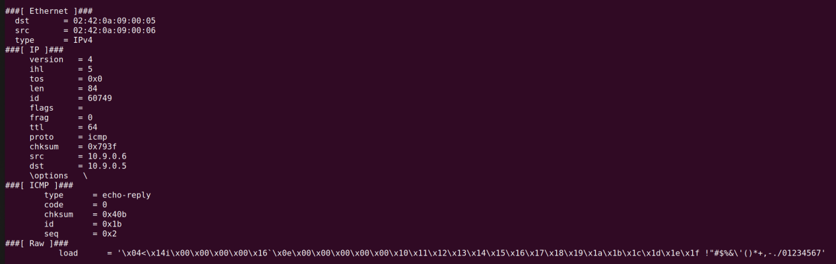

Then test the telnet from host A to host B.
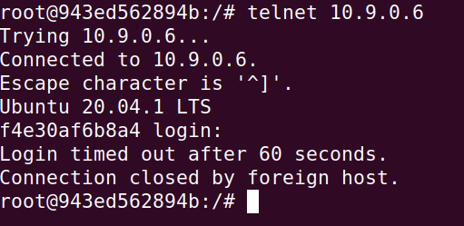
We can see that the packet capture by scapy appear clearly.
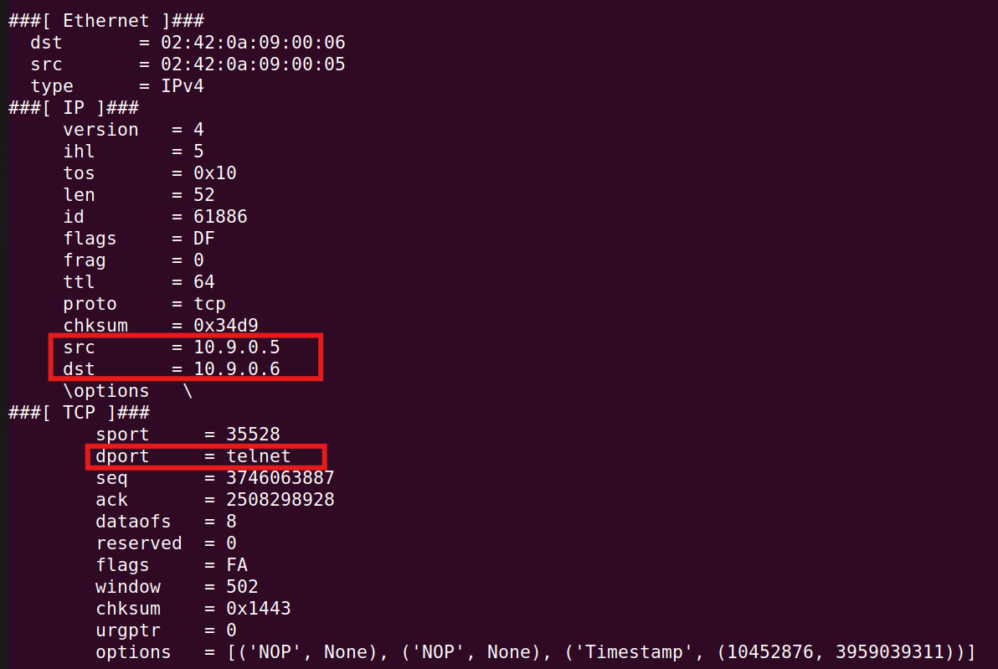
Now lets modify the python file to source ip 10.9.0.6 (Host B). Then run it.
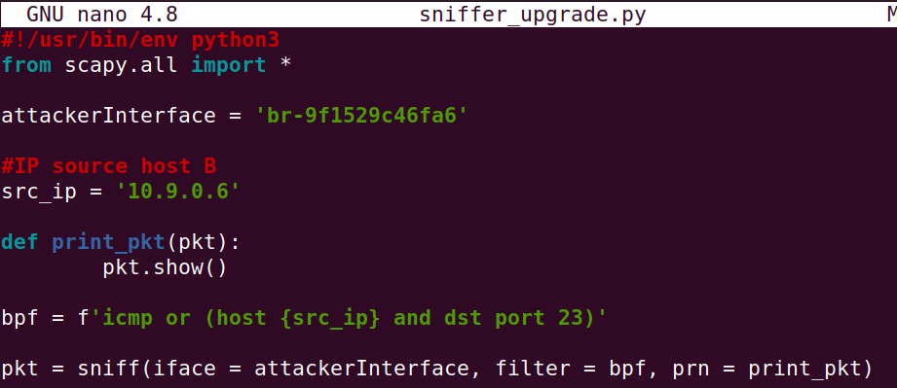
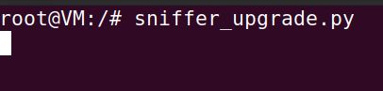
Generate the ping from host B to host A.
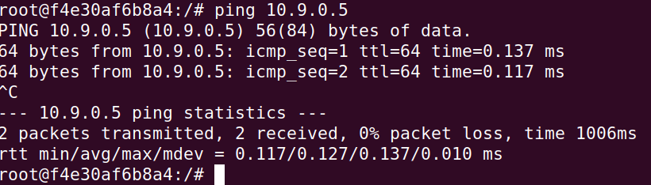
Ping from host B to host A log.
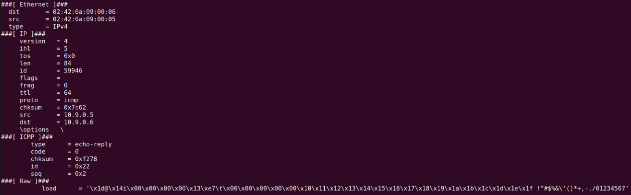
Then test telnet from host B to host A.
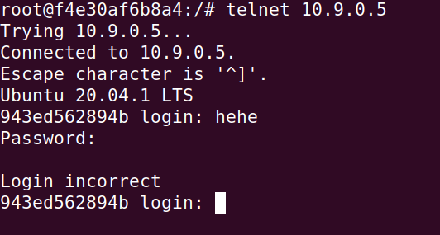

We can see that the packet capture by scapy appear clearly.
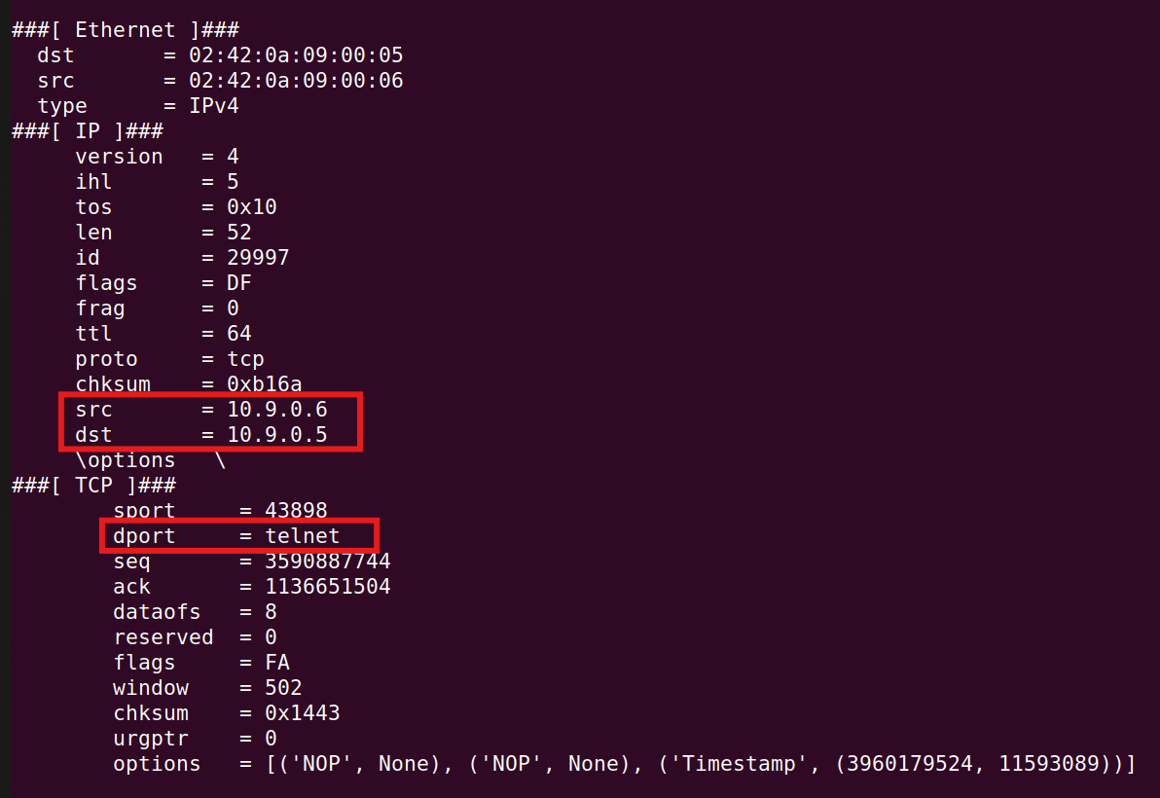
Also I noticed that in this task, I just capture the telnet form one host so I want to test what would happen I have just filter telnet. Because if I just filter one host I cannot see the username or password the user input.
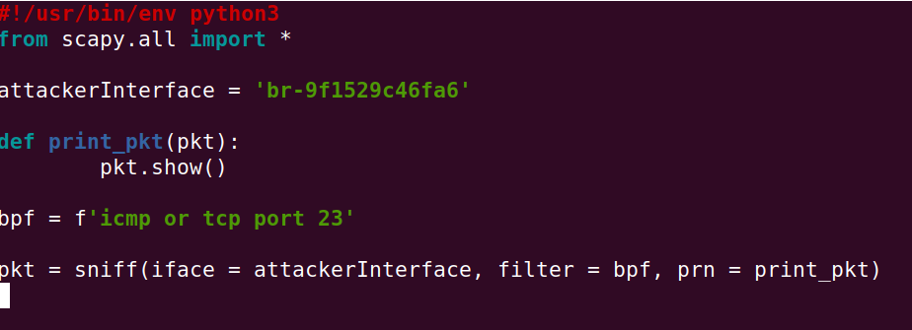

So as my expected, I can see what the user input in the “load” field.
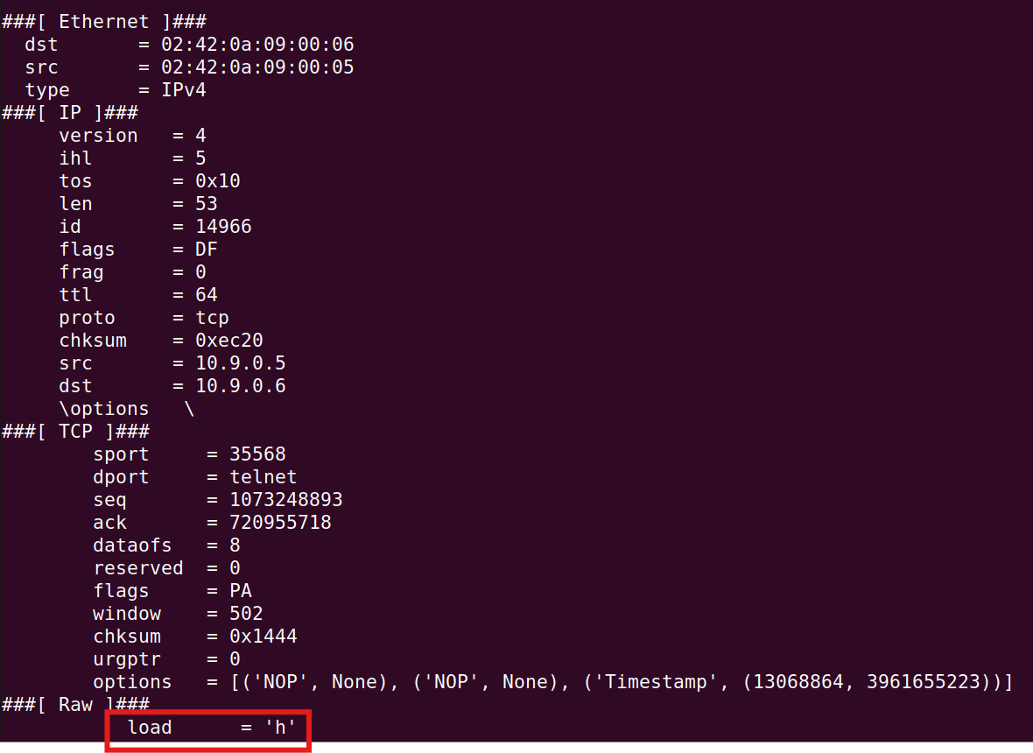

Then I received the Login incorrect, it also appear in the scapy packet log in the “load” field.
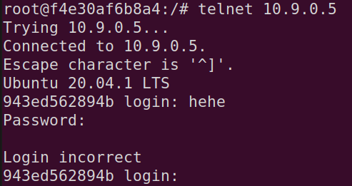
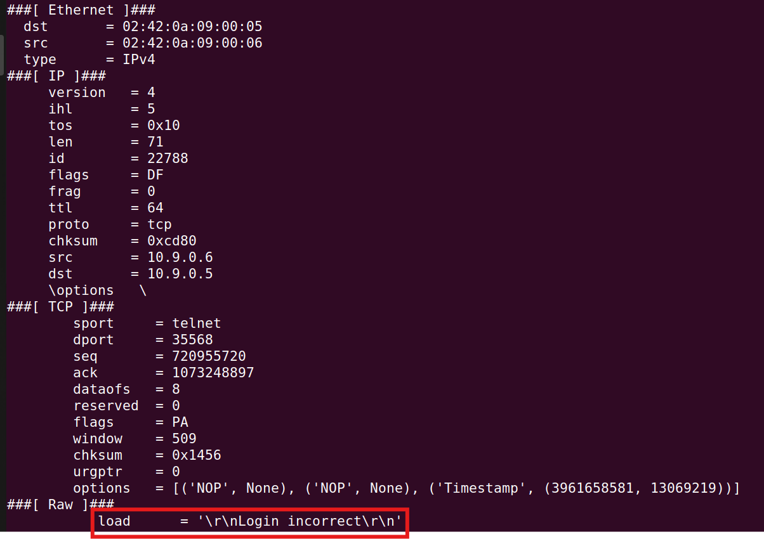

Okay, done this taks 4, realy intersting and it made my curiosity explode, so I have to do a small test
with telnet, really entertaining.

Task 5:
In task 5, I will use scapy to generate a fake icmp echo request, then using wireshark to see if that packet is accept or reject.
I have modified the code , also I have included the payload to test what I have learned in task 1.
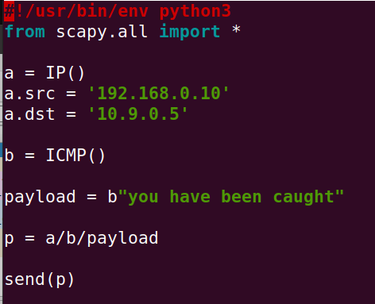

Before running the spoof_icmp.py, I have to turn on tshark on the Host A first to listen for the packet.
tcpdump -i eth0 icmp -vv -X
And also turn on the wireshark on my host machine, then choose the attacker network interface
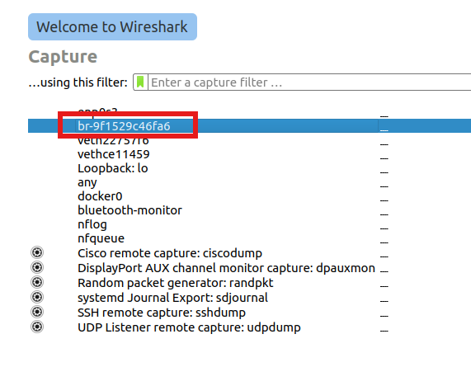
Running the spoof_icmp.py file.
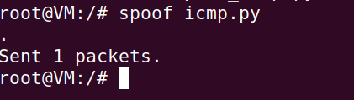
I can see the fake IP address 10.9.0.10 there, the ICMP echo request, and the payload I have been sent, because the option -X in the tcpdump, it will output hex(left) and ASCII(right).
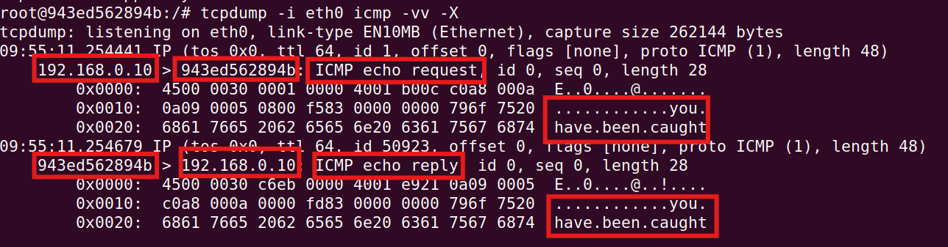
And we can also see all the traffic in the wireshark using the attacker network interface.
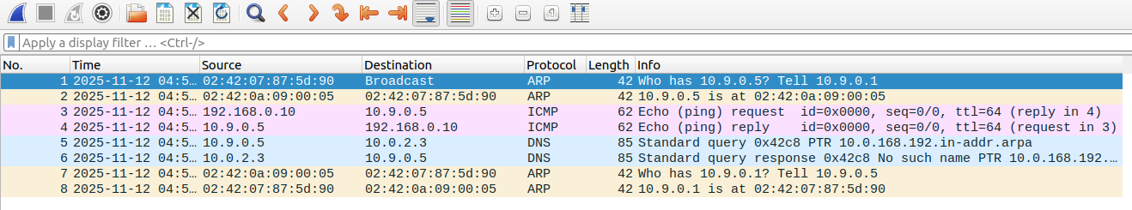

The payload will also appear in the wireshark.
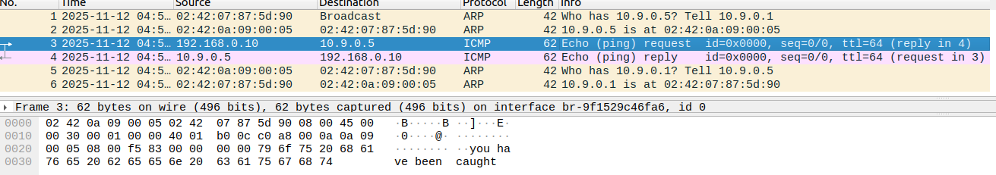

This task 5 give me more knowledge about scapy and how can I make a fake packet with it, I can craft a fake icmp packet then hide the payload, I will enhance my payload to not appear in ASCII in the future, with that I can send message through netrwork without anyone know.

But when do this lab I noticed that if I use the network with same n network with the Host, it will lead to ARP not response, then there will be no ICMP echo reply. I will show below.
Modified the source IP to 10.9.0.10
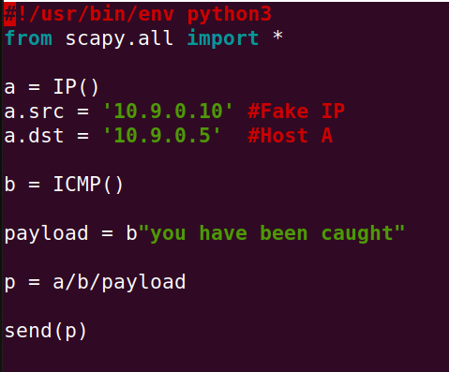
Executed the python file.
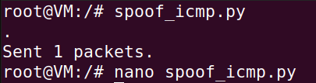
Then lets look at the tcpdump in Host A. It just show the ICMP echo request from a fake IP, not any ICMP echo reply.
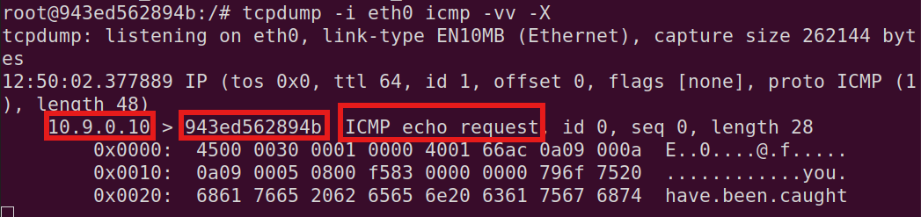
Lets use wireshark to see what happened.
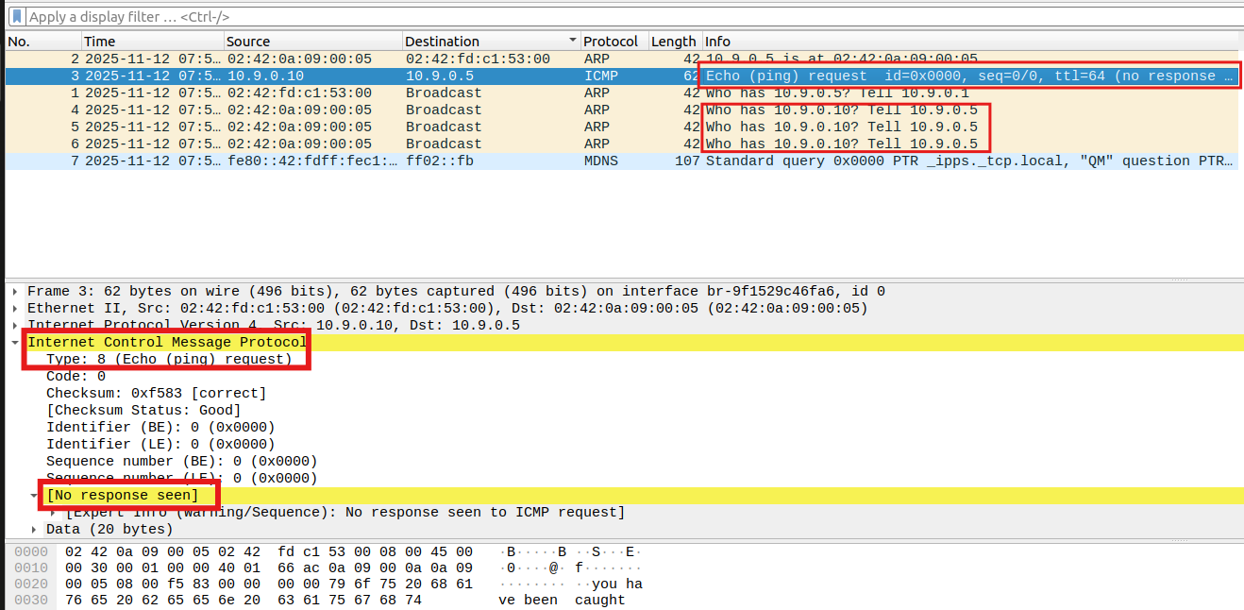
Clearly here, we can see that there is no response for the icmp echo reply, the arp requests also have no response too, then this is how the fake IP fail.

Woah so interesting, this task made me feel crazy, scapy, network, security are so fun, after finishing this task I have more knowledge about scapy and network. The ICMP is just a small protocol that I just use everyday to test the router, and my network, but after this thing I have another perspective abot ICMP now.

Task 6:
In this task, I will craft a simple sniff and spoof python file with scapy.
This is the code that I vibe coding with gpt (HUHU).
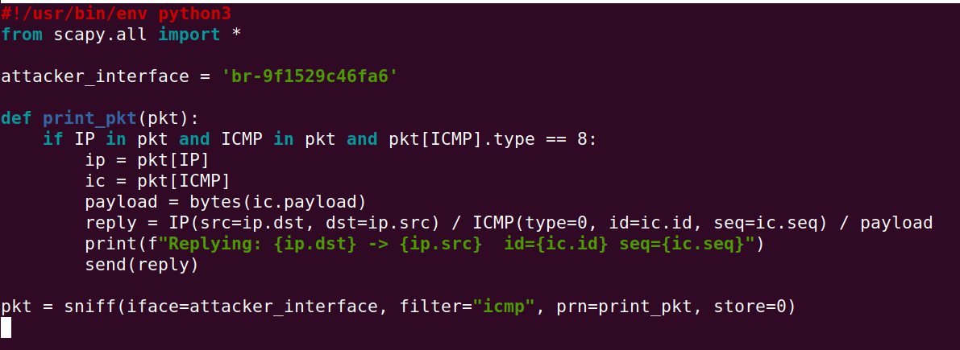
So I will run it to capture all traffic and then send an icmp echo reply automatically to the host send icmp echo request.
Ping from Host A to Host B. When I used the command ping from hsot A, and then ended it whenit send 1 packet, I see that there is a duplicate reply packet, that means someone is sniffing and spoofing the network
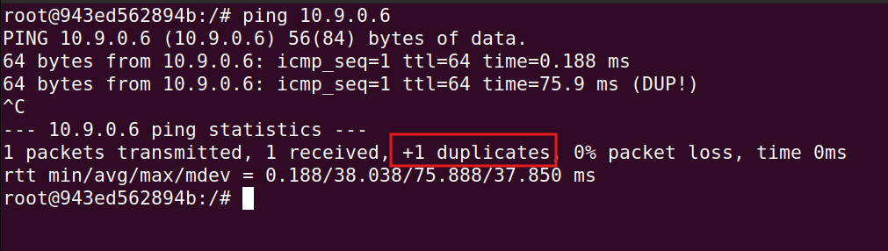
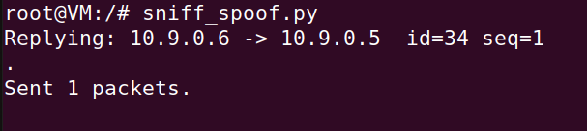
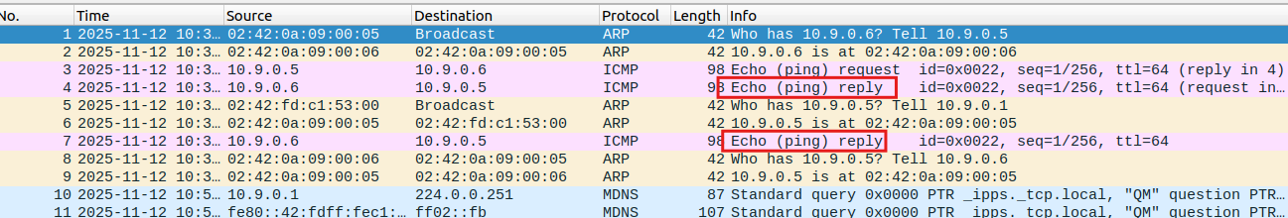

Move to the next objective, I have to reply with all IP that victim ping to, reply with an ICMP echo reply for that none existence IP.
So I have to modified my sniff_spoof.py a little bit (another vibe coding with gpt session (HUHU)).
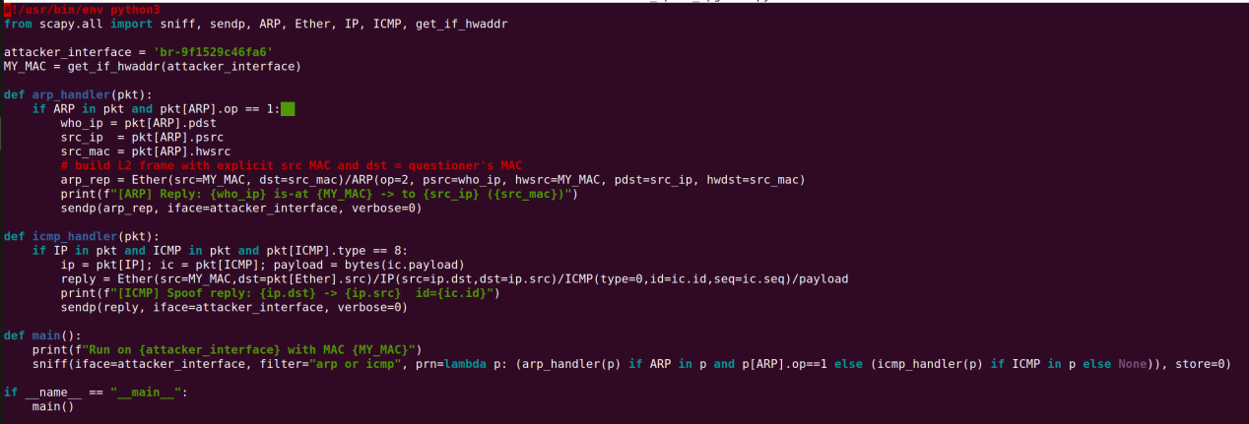
In this part, I also split it into two parts. The first one is the network outside the host subnet and the second one is the network that in the same subnet of the host.
Okay, now lets do the first one.
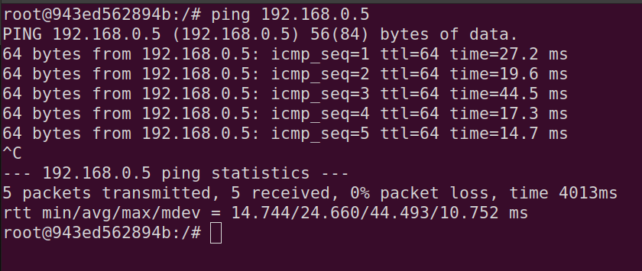
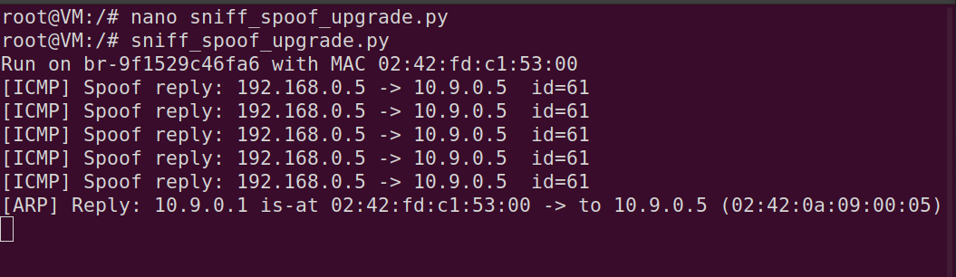
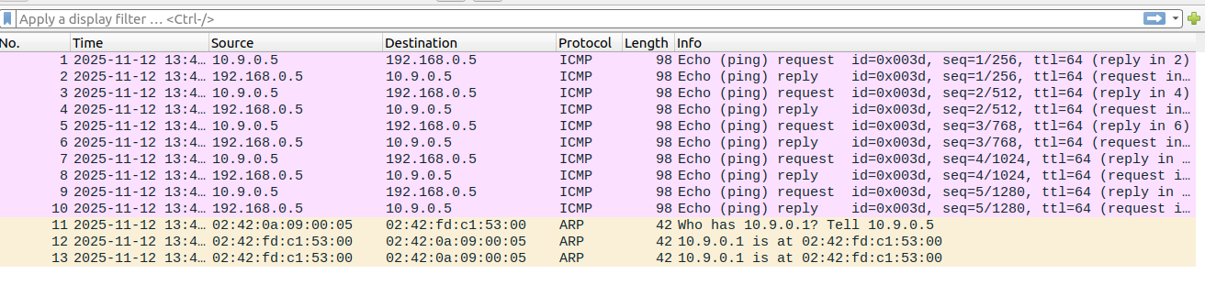
We can see clearly that, the echo reply appear normally, nothing suspicious. The seq, ttl, and time look like a real one so it hard to detect if the end user is not good about technical.
Now, lets move to the second part.
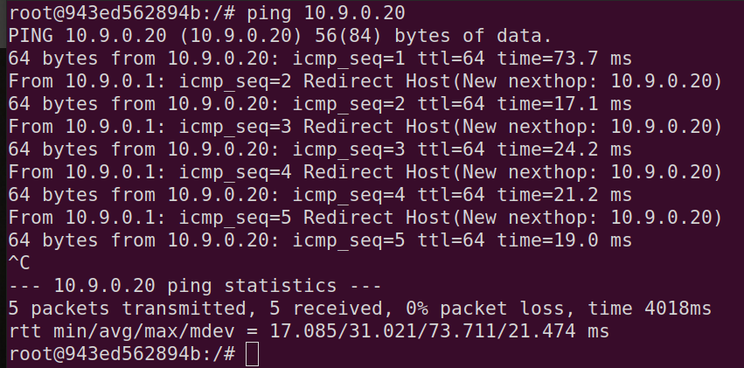
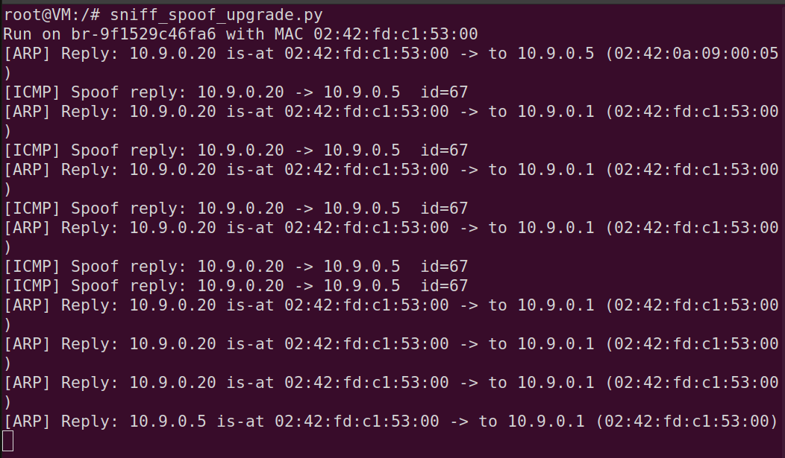
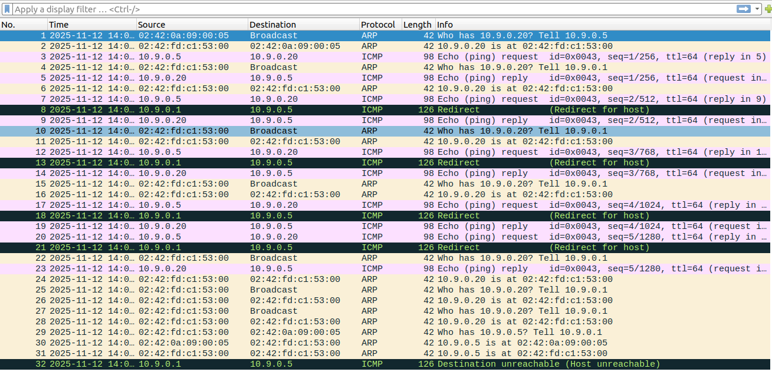

The attacker runs a dual ARP/ICMP spoofing agent on the attacker interface. When a host ping the address 10.9.0.20 the agent replies with an ICMP echo reply that maps 10.9.0.20 to the attacker’s MAC address, poisoning the victim’s ARP cache. Because 10.9.0.20 is on the same subnet, hosts attempt to deliver packets directly at L2; to simulate a real ping response the attacker also forges ICMP Echo-Reply frames. The forged replies preserve the original ICMP id and seq values and use Ethernet src = attacker MAC, IP src = 10.9.0.20, and destination set to the victim’s MAC, so the victim’s ping utility accepts them as legitimate. The packet capture therefore contains a mixture of ARP activity, attacker ARP replies, and attacker-generated ICMP replies; router-generated ICMP Redirects or “new nexthop” events appear because the network topology or forwarding behavior is altered by the spoofing.

After testing with the real IP for host, now I will generate a fake IP source packet, then send it to Host A, I used host B to do this.I want to know that if it a fake source so can scapy send a packet to that fake host.(Pretending that Host B is a new attacker 2.0 (HEHE))(illusion).
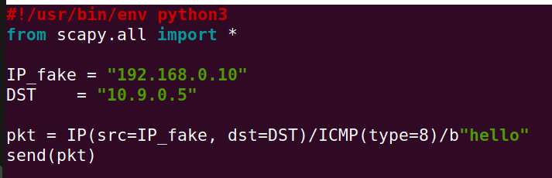
Host B executed the python file.
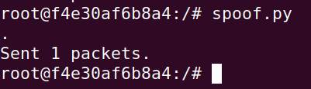
Host A listened and then replied with an echo reply packet. ( same in task 5 )
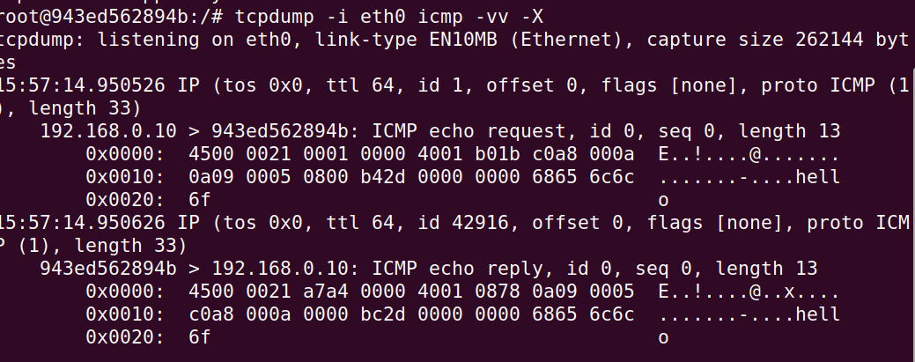
The thing here is that it when I looked at wireshark I did not see the ICMP echo reply packet that scapy spoof to the fake source . That really made me concern, then with a little searching I know that it cannot because the library it uses.
“Scapy sends a packet by first constructing it as a Python object with user-defined headers and payload, then passing the raw bytes via libpcap to the kernel. With send() at Layer 3, the kernel validates the source IP—dropping it silently if fake—before routing and transmission through the NIC driver. In contrast, sendp() at Layer 2 bypasses IP validation, injects the full Ethernet frame directly to the NIC, and when monitor=True is used, forces loopback into the receive path so Wireshark captures the transmitted packet.My spoof packet wasn’t seen because send() with a spoofed source was discarded by the kernel before ever reaching the wire.”
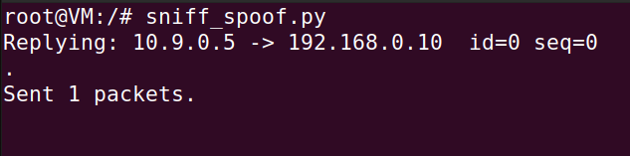
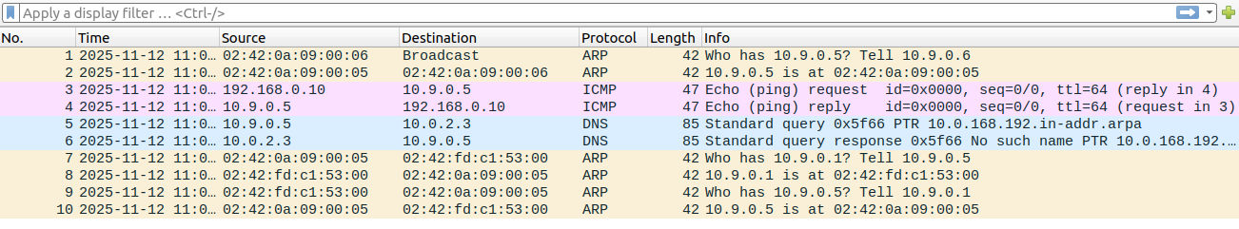

In this task, I did an extra test to see if scapy capture another scapy attack, then can it atatck that scapy attack. This is really fun to do after completing the task objectives. I have tested a lot of scapy functions with ICMP.
This Lab is so interesting to me, I really enjoy doing it!!!.

